CURRICULUM VITAE  Gajendra Singh Jhala  Address: 2-T-35, Talwandi, Kota, Rajasthan  Phone: + 91 7665007050  Passport No.: L5300975  Email: Gajendrajhala89@gmail.com |  | 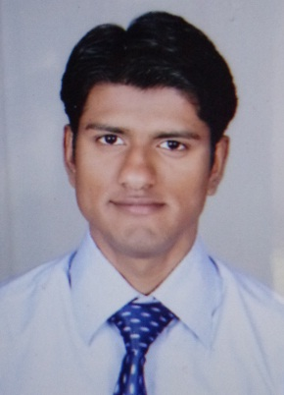
Objective | Looking for a entry into a level profile, organization where I can use my knowledge . Base as well as personal attributes to achieve the organizational goals.
Educational  Qualification  SUMMARY OF  SKILLS  Operating  Skills  Summer Internship | Cooperative and patient  Self motivated  Adaptable and eager to learn new things  Optimistic, Hardworking  Operating Systems : Windows XP, 7, Internet , Ms-word,  Ms-Excel, Ms-PowerPoint, tally 9.0  Company Name :- HDFC BANK  Project Name :- Liability product of HDFC bank  Duration :- 30 days
  Degree | Discipline/ Specialization | Institution | Year | University/ Board
  M.B.A.  (PGDM) | FINANCE | Indore Indira Institute of Business Management | 2012 | AICTE
  B.com | Commerce | Govt. Commerce  College, (Rajasthan) | 2010 | Kota University
  Intermediate | Commerce | M.B.V.B. (Raj.) | 2007 | Board Of Sec. Education Rajasthan
  Matriculation | All subject | M.B.V.B. (Raj.) | 2005 | Board Of Sec.  Education  Rajasthan
Projects  Experience  Additional  Qualification  Personal Details | Project of brick making business plan and analysis of profit margin or future Aspect to the business  Project on situation analysis, evaluation, ratio, leverage, cost of capital,  structure maintenance & budgeting of MRF tyres  Project undertaken of furniture manufacturing business  Comparative research analysis on Air India airlines or Kingfisher  Marketing research project on Big Bazaar  1 Year experience in ICICI securities ltd. In Mumbai As senior relationship  manager  Currently working in Kamal Auto Finance LTD. as Marketing Manager  Certificate of N.S.S. from Govt. commerce college  Certificate on retail marketing from G.O.L.S. academy  Certificate of EPTSE from E. PLUS TUTORIALS  Advance diploma in Insurance and Risk management from Indore Indira Business School  Certification of attending a workshop program in ICICI securities ltd.  Certification for a successful completion of takeoff in ICICI securities ltd.  Father`s Name :Mr. Kishan Singh Jhala  Mother`s Name :Mrs. Bhawar kanwar  Date of Birth :02-07-1989  Languages Known :English, Hindi  Permanent address: 2-T-35, Talwandi, Kota  Rajasthan  Marital status : Married  Hobbies : Listening Music , playing chess , Reading books
Date: signature

